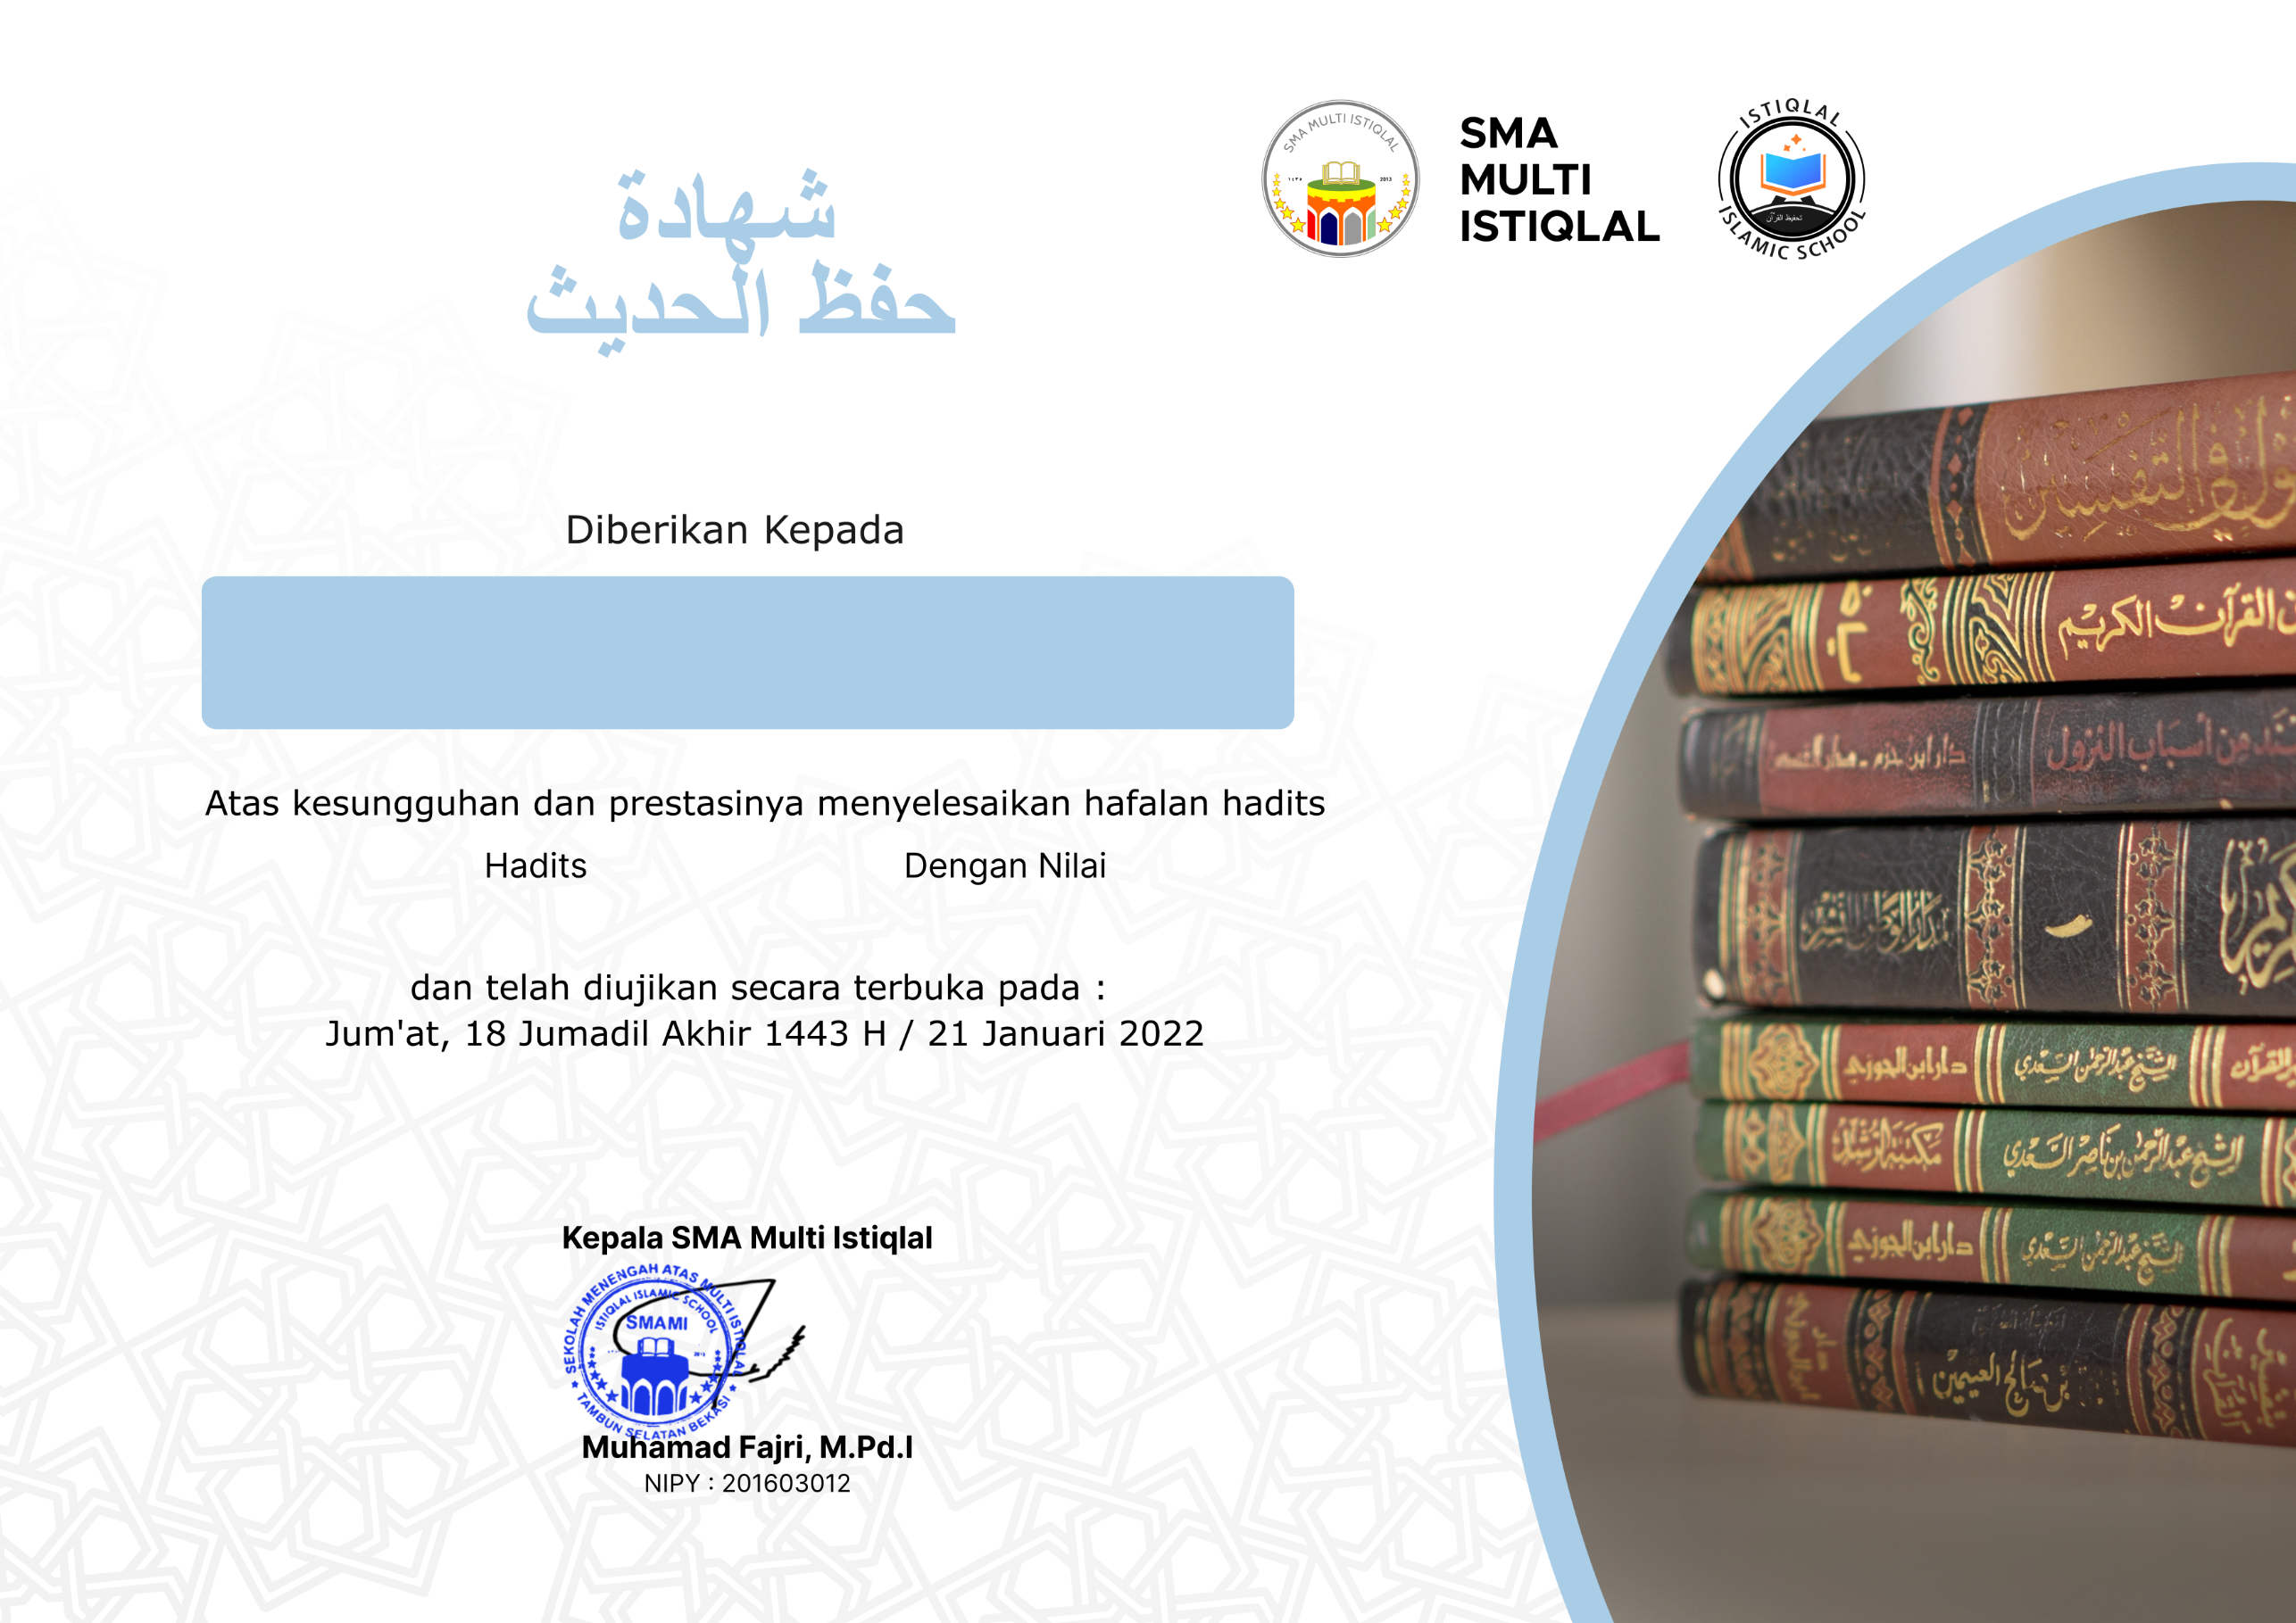

**Habibah Kayysa Syakura**

**جَيِّدْ (83)**

**100**